**Install GIT & make sure it is added into PATH.**

**Use GIT as local VCS. Steps to follow:**

1.Create a directory ‘project_dir’ & cd to ‘project_dir’.

* Open git bash and make project_dir using mkdir cmd

2.Initialize git version database.

* Enter git init command creates a new Git repository

3. Create a new file index.html.

* Using touch cmd I had created index.html

Content added in index.html

4. Check the git status. You should find index.html as untracked file.

* Git statuts used for to check current status of directory

5. Stage the index.html file.

* git add cmd used for to add staging area

6. Commit index.html

* by using git commit cmd I had committed index.html

7. Make few changes in index.html & create a new file info.txt file.

* touch info.txt are used for creating file and edited some content indext.html

8. Check git status. You should find index.html & info.txt as untracked files.

* Using git status you can see status of directory

9. Configure GIT to ignore all txt files.

* Create .gitignore file and add files that you need to hide

10. Again check the git status. You should find only index.html as untracked file.

* Create .gitignore file and add files that you need to hide

11. State & commit index.html

* Git commit -am cmd is used for add and commit in single cmd

12. Log all your comments so far.

* git log used for to see commit history

13. Make some changes in index.html.

* made some changes in index.html

14. Revert the change made in the previous step using git command.

* Git check – index.html used for undoing recent change

* Here you can see recently added line was removed

15. Again change index.html.

* Again Capgemini training was added

16. Stage index.html

* git add used to staging area

17. Revert back the last stage.

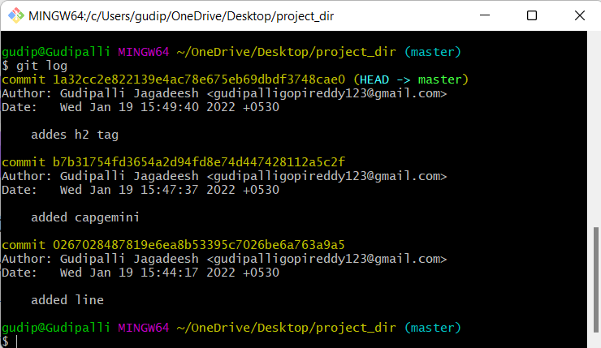

18. Rename ‘add’ command to ‘my-add’.

* To rename any command we have use alias names

19. Using my_add command Stage index.html again & commit the changes.

20. Revert the last commit.

* To revert last stage copy commit id

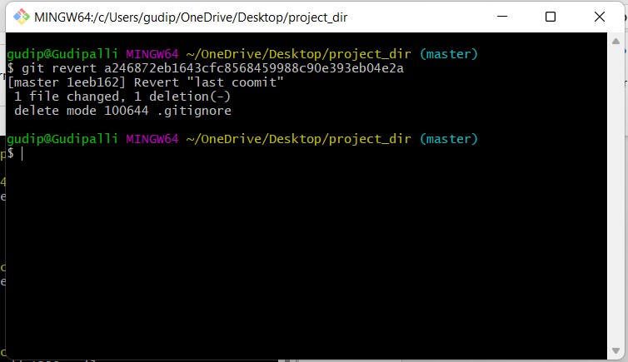

**GIT Branching**

Objective: Commit HTML, CSS & JavaScript assignments into GIT.

**SECTION-1 (HTML assignments) - Steps to follow:**

21. First take a backup of your assignments & projects. This is required because due to incorrect GIT operation you may lose your files.

* I had taken backup my assignment folder into google drive

22. Create an empty directory ‘Assignments’ & cd to ‘Assignments’.

23. Create a file README.txt inside ‘Assignments’ & write few lines about the

contents of ‘Assignments’ folder.

24. Commit README.txt file.

25. Now create a new branch ‘html-assignments’.

26. Switch to ‘html-assignments’ branch.

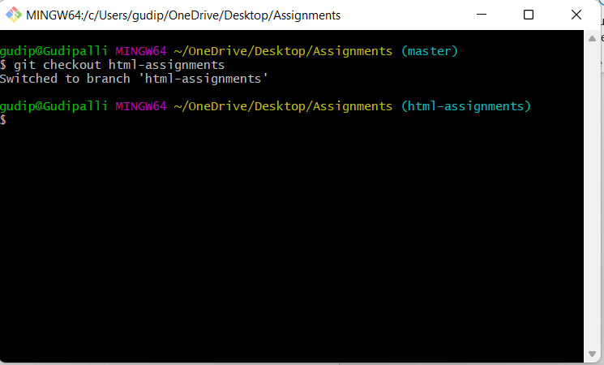

27. Copy all HTML assignments inside ‘Assignments’ folder.

28. Commit HTML assignments into ‘html-assignments’ branch.

29. Make minor changes into few files belonging to ‘html-assignments’ branch.

30. Commit those changed files.

31. Switch to master branch.

32. Make minor changes into README.txt file & commit those changes into master.



33. Again switch to ‘html-assignments’ branch.



34. Make minor changes into few files belonging to ‘html-assignments’ branch.

35. Commit those changes.

36. Switch to master.

37. Merge ‘html-assignments’ branch into master. Confirm all html assignments are shown in master.

38. Finally delete the ‘html-assignments’ branch.git

**SECTION-2 - (CSS assignments) Steps to follow:**

1. Create a new branch ‘css-assignments’.

2. Switch to ‘css-assignments’ branch.

3. Copy all CSS assignments inside ‘Assignments’ folder.

4. Commit CSS assignments into ‘css-assignments’ branch.

5. Make minor changes into README.txt file on line 1 belonging to ‘css-assignments’ branch.

6. Commit those changed files.

7. Switch to master branch.



8. Make minor changes into README.txt file on line 3 & commit those changes into master.

9. Again switch to ‘css-assignments’ branch.



10. Make minor changes into few files belonging to ‘css-assignments’ branch.

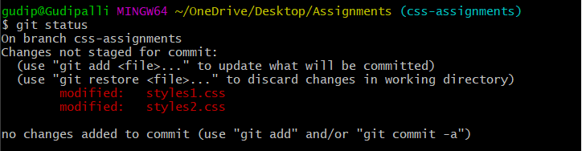

11. Commit those changes.

12. Switch to master.

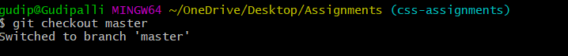

13. Merge ‘css-assignments’ branch into master. Confirm all css assignments are shown in master.



14. Finally delete the ‘css-assignments’ branch.

**SECTION-3 - (JavaScript assignments) Steps to follow:**

1. Create a new branch ‘js-assignments’.

2. Switch to ‘js-assignments’ branch.

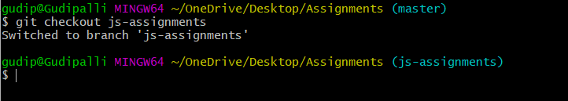

3. Copy all JavaScript assignments inside ‘Assignments’ folder.

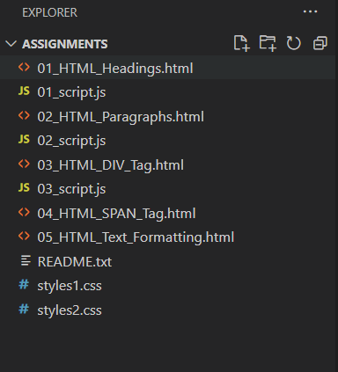

4. Commit JavaScript assignments into ‘js-assignments’ branch.

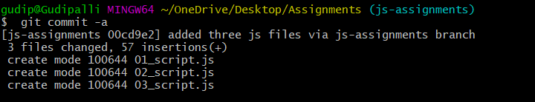

5. Make minor changes into README.txt file on line 1 belonging to ‘js-assignments’ branch.

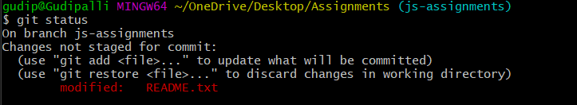

6. Commit those changed files.

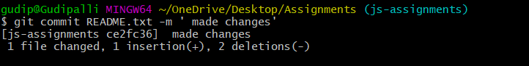

7. Switch to master branch.



8. Make minor changes into README.txt file on line 1 & commit those

changes into master.

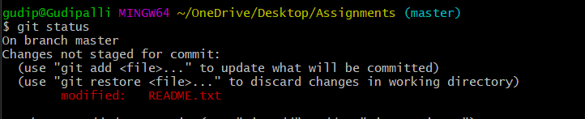

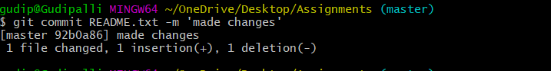

9. Again switch to ‘js-assignments’ branch.



10. Make minor changes into few files belonging to ‘js-assignments’ branch.

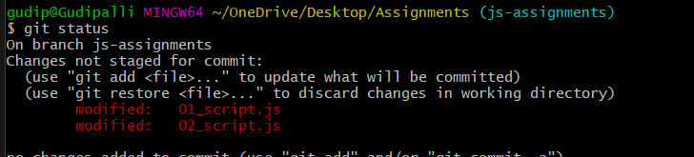

11. Commit those changes.

12. Switch to master.



13. Merge ‘js-assignments’ branch into master. Confirm all JavaScript

assignments are shown in master.

14. Finally delete the ‘js-assignments’ branch.



**GIT Remoting**

Objective: Pushing source code into GITHUB & collaborate team members.

**SECTION-1 (Pushing assignments to remote repository) - Steps to follow:**

39. Create a github account if you do not have already.

40. Login on into github account.

41. Create new public repository ‘freshersbatch-oct16’.

42. Commit & push any sample file to this repository under ‘Assignments’ directory.

------------------------------------THE END------------------------------------------